**Database Design**

create a database on the Patient Care System. It will help to manage the below functionalities.

* Patient details
* Doctor details
* Staff details
* Appointments
* Medicine
* Payment

We will use MySQL as the DBMS to create the database and its related operations.

**1. Introduction to MySQL**

MySQL is an open-source relational database management system (RDBMS) that uses structured query language (SQL) to manage and manipulate data in a database. It is widely used for various applications, from small web applications to large enterprise systems.

MySQL's key features include:

* Scalability: Capable of handling large amounts of data and concurrent connections.
* Flexibility: Supports various data types and storage engines.
* Performance: Optimized for speed and efficiency.
* Reliability: Known for its stability and robustness.

**2. Installation of MySQL**

MySQL can be installed on various operating systems, including Windows, macOS, and Linux. Here are the general steps to install MySQL:

**Windows:**

* Download the MySQL installer from the official website.

<https://dev.mysql.com/downloads/installer/>

* Run the installer and follow the on-screen instructions.
* Choose the installation type (Typical, Complete, or Custom). Recommended Custom.
* Set a root password for the MySQL server.

**3. E-R Diagram (ERD)**

An Entity-Relationship Diagram (ERD) is a visual representation of the data model that shows the entities, attributes, relationships between entities, and cardinality. ERDs are commonly used in database design to help developers and stakeholders understand the structure and relationships within a database.

**Identify Entities**

* Patient
* Doctor
* Staff
* Appointment
* Medicine
* Payment

**Define Attributes**

* Patient (pid, name, age, blood, prescription, dose, fees, urgency)
* Doctor (did, dname, dage, daddress, specialization, experience, dnumber)
* Staff (sid, sname, sage, saddress, snumber)
* Appointments (aid, name, age, symptoms, number)
* Medicine (drug_name, stock)
* Payment (pay_id, name, pay_mode, pay_amt, pay_receipt)

**Identify Relationships**

* Determine how entities are related to each other. There are three types of relationships: one-to-one (1:1), one-to-many (1:N), and many-to-many (N:M).
* Represent these relationships using lines connecting the entities.

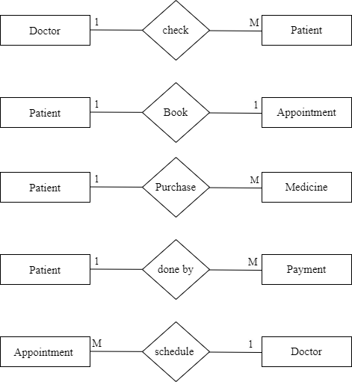

**Add Attributes and Constraints**

* Include additional information in your ERD, such as primary keys, foreign keys, and constraints (e.g., unique constraints).

**Create the Diagram**

* Use specialized diagramming software or tools (e.g., Lucidchart, draw.io, or even pen and paper) to create your ERD.

**Refine and Review:**

Identify the entities of the Patient Care system

* Patient
* Doctor
* Staff
* Appointment
* Medicine
* Payment

**Patient**

* **Attributes:**

pid (Primary Key)

name

age

blood

prescription

dose

fees

urgency

* **Relationships:**

One **Patient** can book one **Appointment** (One-to-One)

One **Patient** can purchase Many **Medicine** (One-to-Many)

**Appointment**

* **Attributes:**

aid (Primary Key)

name

age

symptoms

number

did (foreign key)

pid (foreign key)

* **Relationships:**

Many **Appointment** schedule by one **Doctor** (**Many-to-One**)

**Doctor**

* **Attributes:**

did (Primary Key)

dname

dage

specialization

experience

dnumber

pid (foreign key)

* **Relationships:**

One **Doctor** checks many **Patients** (**One-to-Many**)

**Staff**

* **Attributes:**

sid (Primary Key)

sname

sage

saddress

snumber

pid(foreign key)

* **Relationships:**

One **Staff** observe to Many **Patients** (**One-to-Many**)

**Medicine**

* **Attributes:**

mid (Primary Key)

drugName

stock

pid(Foreign Key)

               did(Foreign key)

* **Relationships:**

One **Medicine** purchase to Many **Patients** (**One-to-Many**)

**Payment**

* **Attributes**:

pay_id(Primary Key)

name

pay_mode

pay_amt

pay_receipt

* **Relationships:**

Many **Patient** will make to many **Payments (Many-to-many)**

**Table Structure**

**1.** **Patient**

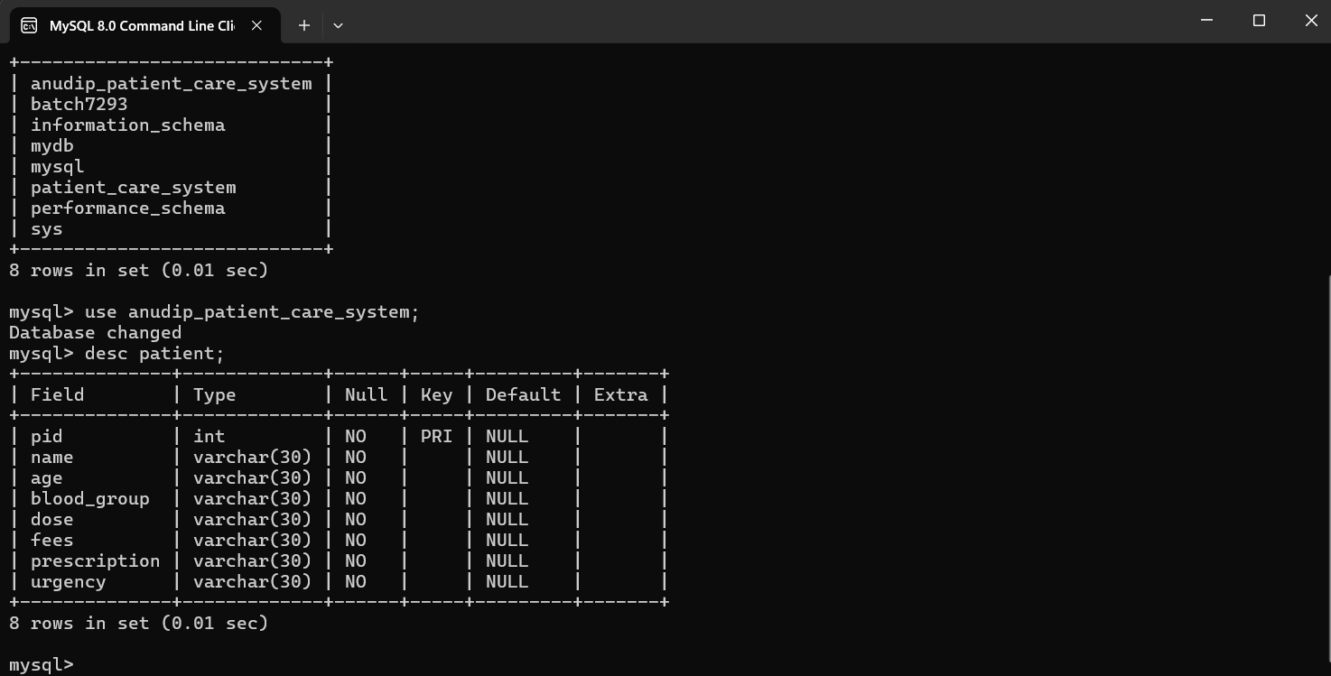

**2. Doctor**

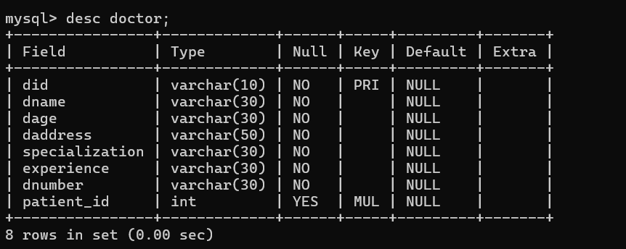

**3. Staff**

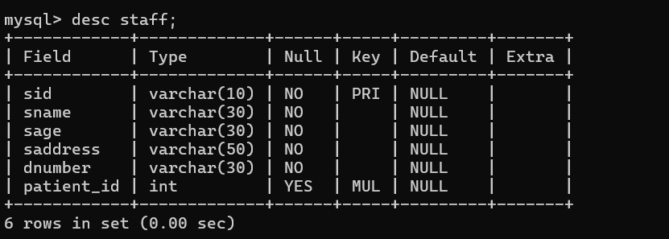

**4. Appointment**

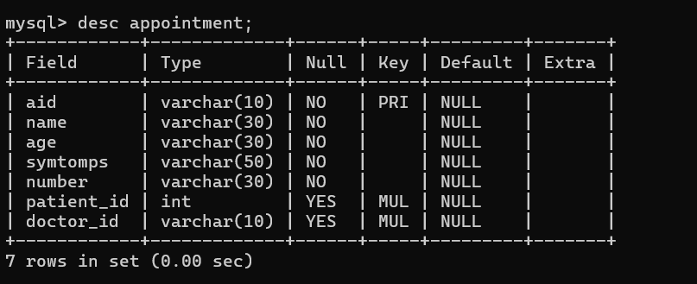

**5. Medicine**

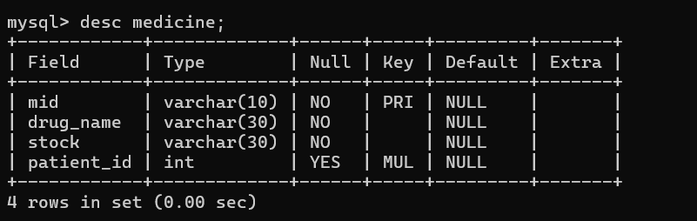

**6. Payment**

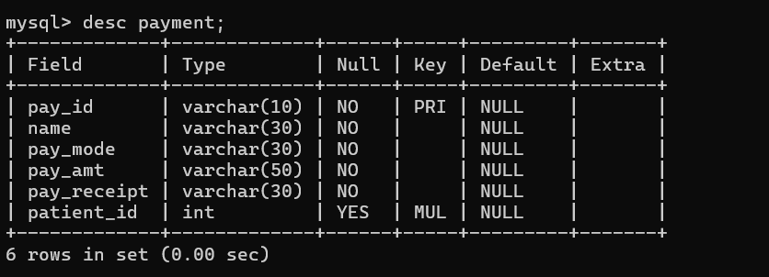

**ERD Diagram**

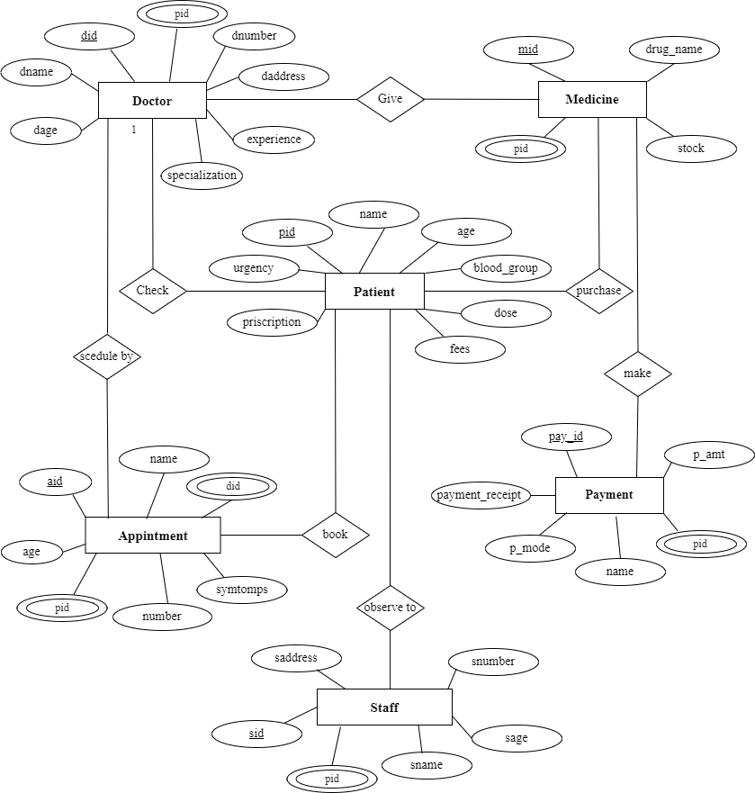

**In this ERD:**

* patient can book appointment and each doctor has check multiple patients, creating a many-to-many relationship.
* The appointment entity serves as a bridge table between patient and doctor entities to represent this relationship.
* Multiple patients can be purchase by Many medicine (many-to-many relationship).
* Each patients can make multiple payments (one-to-many relationship).

**4. Creating a Database**

Using MySQL server, create a new database for your Patient Care System. You can do this with SQL commands or through the graphical interface.

CREATE DATABASE anudip_patient_care_system;

**5. Using a Database**

Before performing any operations on a database, you need to select it using the USE statement:

USE anudip_patient_care_system;

**6. Creating the tables for each entity**

USE anudip_patient_care_system;

create table patient

(pid int primary key,

name varchar(30) not null,

age varchar(30) not null,

blood_group varchar(50) not null,

dose varchar(30) NOT NULL,

fees varchar(30) not null,

prescription varchar(30) not null,

urgency varchar(30) not null);

create table doctor

(did varchar(10) primary key,

dname varchar(30) not null,

dage varchar(30) not null,

daddress varchar(50) not null,

specialization varchar(30) not null,

experience varchar(30) not null,

dnumber varchar(30) not null,

patient_id int,

CONSTRAINT FK_patientID foreign key(patient_id)

references patient(pid));

create table staff

(sid varchar(10) primary key,

sname varchar(30) not null,

sage varchar(30) not null,

saddress varchar(50) not null,

dnumber varchar(30) not null,

patient_id int,

CONSTRAINT FK_patient_ID foreign key(patient_id)

references patient(pid));

create table appointment

(aid varchar(10) primary key,

name varchar(30) not null,

age varchar(30) not null,

symtomps varchar(50) not null,

number varchar(30) not null,

patient_id int,

CONSTRAINT FKpatientID foreign key(patient_id)

references patient(pid),

doctor_id varchar(10),

constraint FKdoctorID foreign key(doctor_id)

references doctor(did));

create table medicine

(mid varchar(10) primary key,

drug_name varchar(30) not null,

stock varchar(30) not null,

patient_id int,

CONSTRAINT FKpatient_ID foreign key(patient_id)

references patient(pid));

create table payment

(pay_id varchar(10) primary key,

name varchar(30) not null,

pay_mode varchar(30) not null,

pay_amt varchar(50) not null,

pay_receipt varchar(30) not null,

patient_id int,

CONSTRAINT PatientID foreign key(patient_id)

references patient(pid));

**7. Insert records**

Add data to your tables to work with. This step helps you test your database.

**-- Insert patient**

INSERT INTO patient (pid, name, age, blood, prescription, dose, fees, urgency) VALUES

(1, 'Akanksha', '23', 'AB+', '1st dose', '2000', 'Stay Tension Fee', 'Yes');

(2, 'Sunny', '21', 'O+', '2st dose', '3000', 'Avoid Oily Foods', 'Yes');

(3, 'Nivedita', '25', 'A+', '3st dose', '1000', 'Avoid Noise', 'Yes');

(4, 'Shriyank', '15', 'B+', '1st dose', '500', 'Stay pollution free place', 'No');

(5, 'Siya', '10', 'AB-', '1st dose', '2000', 'Stay Tension Fee', 'Yes');

(6, 'Shravani', '19', 'O-', '2st dose', '1000', 'Stay Tension Fee', 'No');

**-- Insert doctor**

 INSERT INTO Doctor (did, dname, dage, daddress, specialization, experience, dnumber) VALUES

( 'D-01','Dr.Asmita Bhosale','30','Satara','Dentalist','10 years','9856321047', 1);

('D-02','Dr.Varsha Chavhan','35','Pune','Eye-specialist','9 years','8965412369', 2);

('D-03','Dr.Kishor Bhise','40','Mumbai','Ayuvedic','15 years','9856748596', 3);

**-- Insert staff**

INSERT INTO Staff (sid, sname, sage, saddress, snumber) VALUES

('S-01','Amit Pawar','25','Pune','8965478965', 1);

('S-02','kaveri pahade','30','Mumbai','7989562314', 2);

('S-03','Laksh Nikam','38','Satara','7788996655', 3);

**-- Insert Appointment**

INSERT INTO appointment (aid, name, age, symptoms, number) VALUES

('a-01','Akanksha','23','Headache','7854693254', 1, ‘D-01’);

('a-02','Sunny','21','Fever','8899554477', 2, ‘D-02’);

('a-03','Nivedita','25','Headache','8877888877', 3, ‘D-03’);

**—--Insert medicine**

INSERT INTO medicine (drug_name, stock)VALUES

('m-01','Crocin','100', 1);

('m-02','Paracetamol','200', 2);

('m-03','acetaminophen','300', 3);

**— Insert Payment**

INSERT INTO Payment(pay_id, name, pay_mode, pay_amt, pay_receipt)VALUES

('p-01','Akanksha','cash','100','Yes', 1);

('p-02','Nivedita','cash','200','Yes', 2);

('p-03','Sunny','cash','300','Yes', 3);